**DAILY ONLINE ACTIVITIES SUMMARY**

|  |  |  |  |  |  |  |  |
| --- | --- | --- | --- | --- | --- | --- | --- |
| **Date:** | | **28/5/2020** | | | | | |
| **Name of the Faculty** | | **REENA LOBO** | | | | | |
| **No. of Students Allotted for monitoring** | | | | | **19** | | |
| **Progress** | | | | | **GOOD** | | |
| **Whether collected report from all the allotted students** | | | | | **18** | | |
| **Online Test Summary** | | | | | | | |
| **Subject** | **OPERTING SYSTEM IA2** | | | | | | |
| **Semester** | **6** | | | **Duration** | | **40MIN** | |
| **No. of students Taken** | | | **102** | **Passing %** | | **98** | |
| **Certification Course Summary** | | | | | | | |
| **Course** | | Attended webinar on The Future of Artificial Intelligence -1hrattended webinar on cyber securityCertification provider:K7 academy-1hr.. | | | | | |
| **Certificate Provider** | | **ICT ACADEMY** | | | **Duration** | |  |
| **Coding Challenges** | | | | | | | |
| **Problem Statement: Write a function that accepts a string consisting entiring of brackets ({}) and returns whether it is balanced. Every "opening" bracket must be followed by a closing bracket of the same type. There can also be nested brackets, which adhere to the same rule** | | | | | | | |
| **Status: completed** | | | | | | | |
| **Uploaded the report in Github** | | | | | **yes** | | |
| **If yes Repository name** | | | | | <https://github.com/reenalobo/ONLINE-ACTIVITY-REPORT/upload/master> | | |
| **Uploaded the report in slack** | | | | | **yes** | | |

Certification Course Details: (Attach the snapshot and briefly write the report for the same)

**Attended webinar on The Future of Artificial Intelligence**

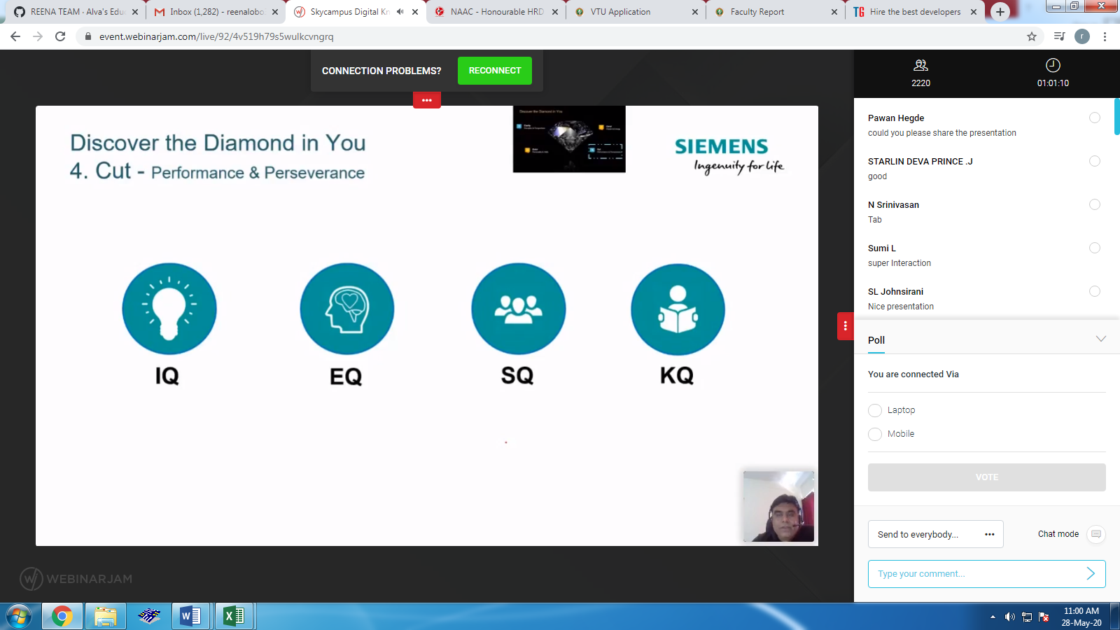

# attended webinar on cyber security-k7 academy

# 

**Online test:**

**Conducted OPERATING SYSTEM IA2 ,out of 110 students 102 students registered and completed the test.100 students passed -98%**

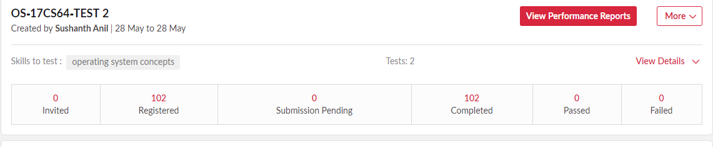

**Coding activity:**

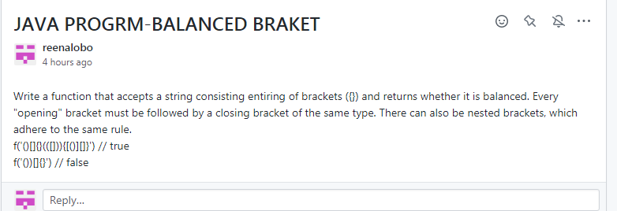

STUDENTS REPORT:

ROHAN MAHAVEER:

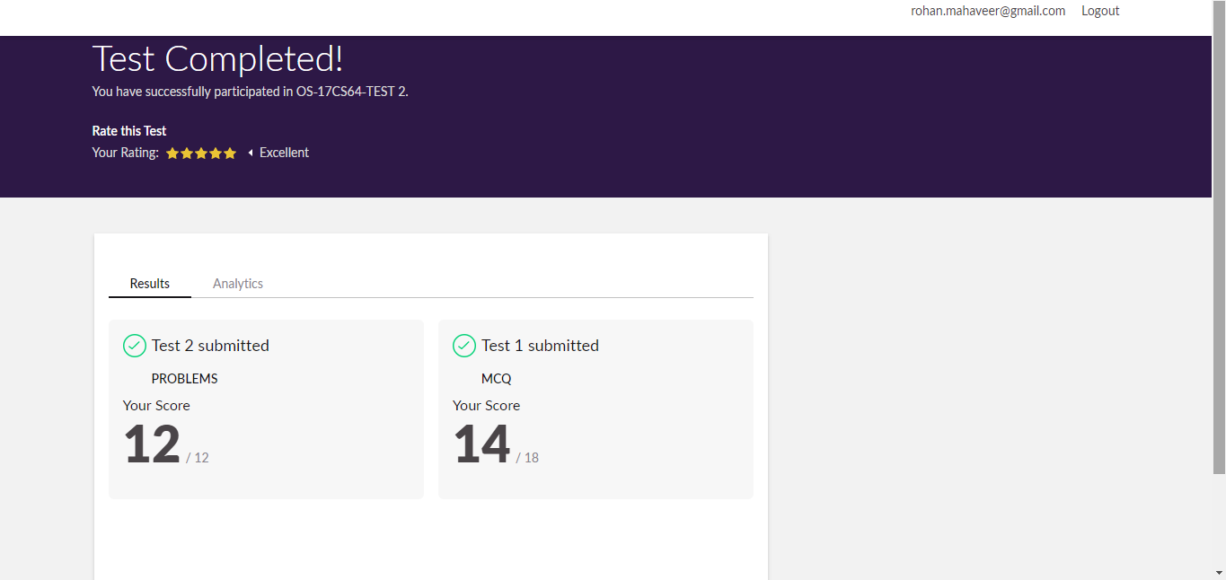

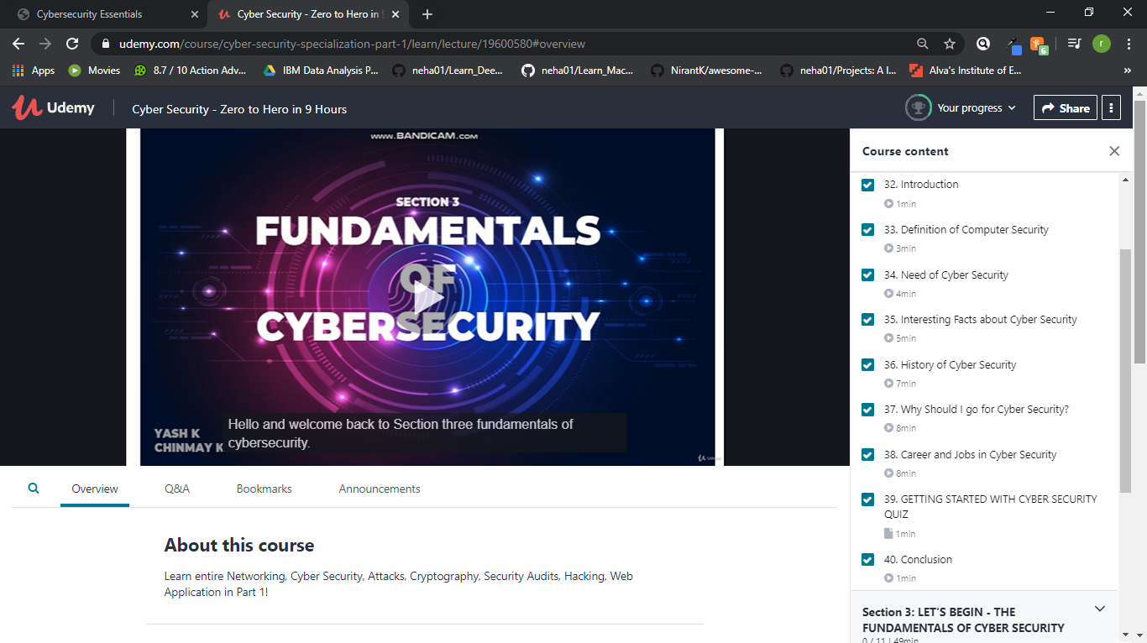

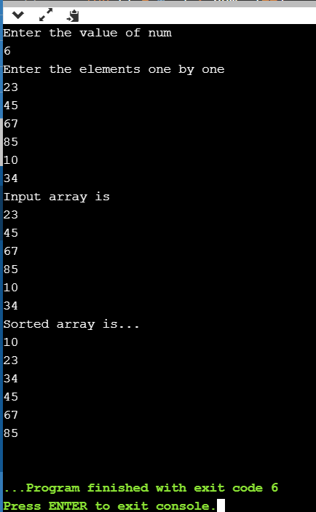

ATISH:

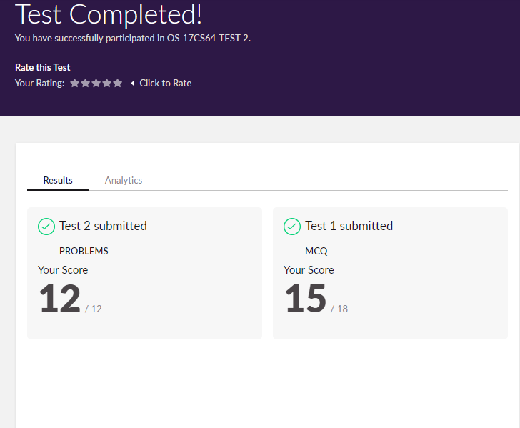

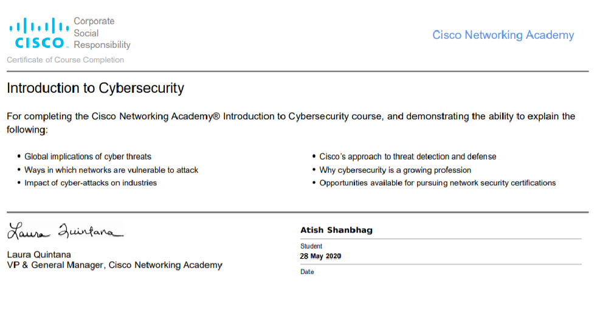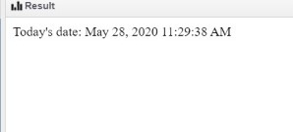

**Shah Dhruvil Amit:**





**Raksha S:**

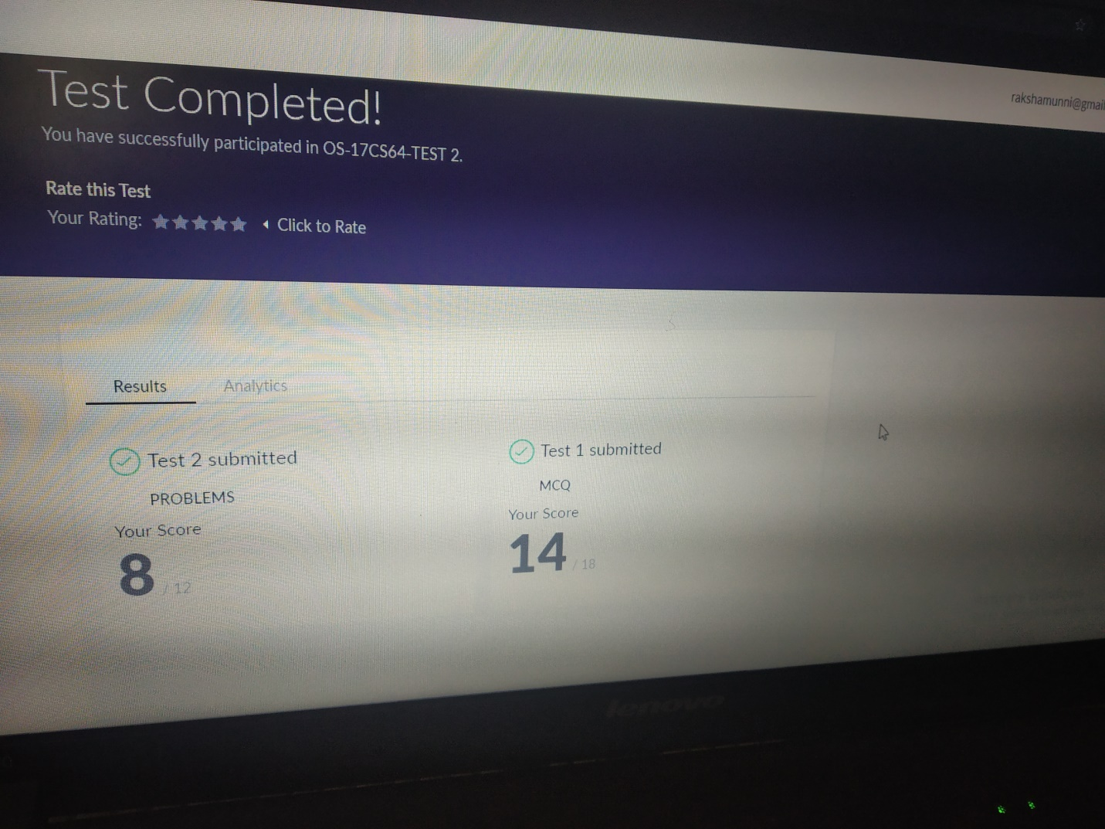

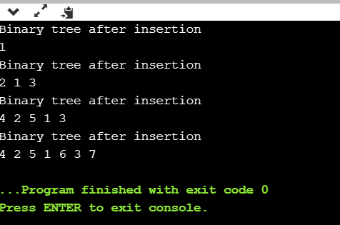

**Preethi:**

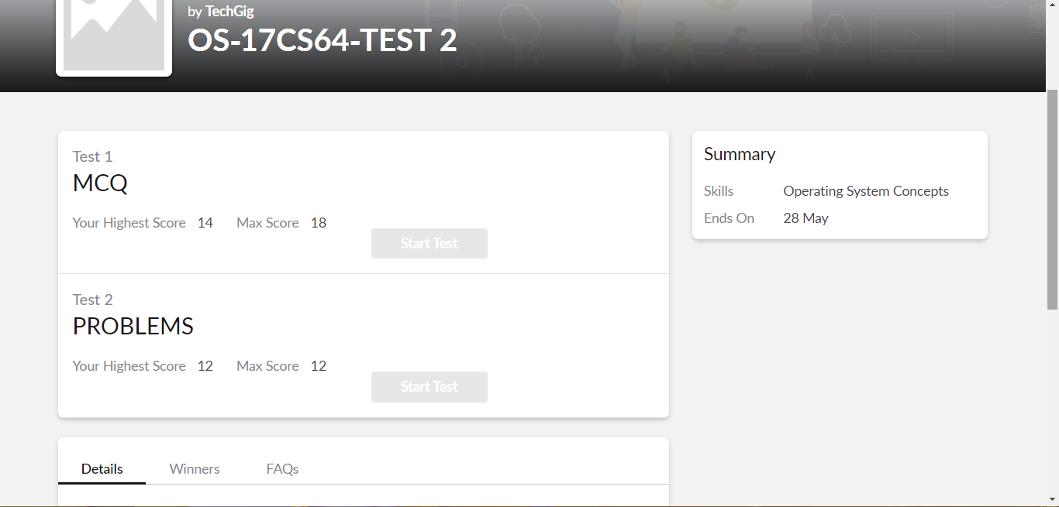

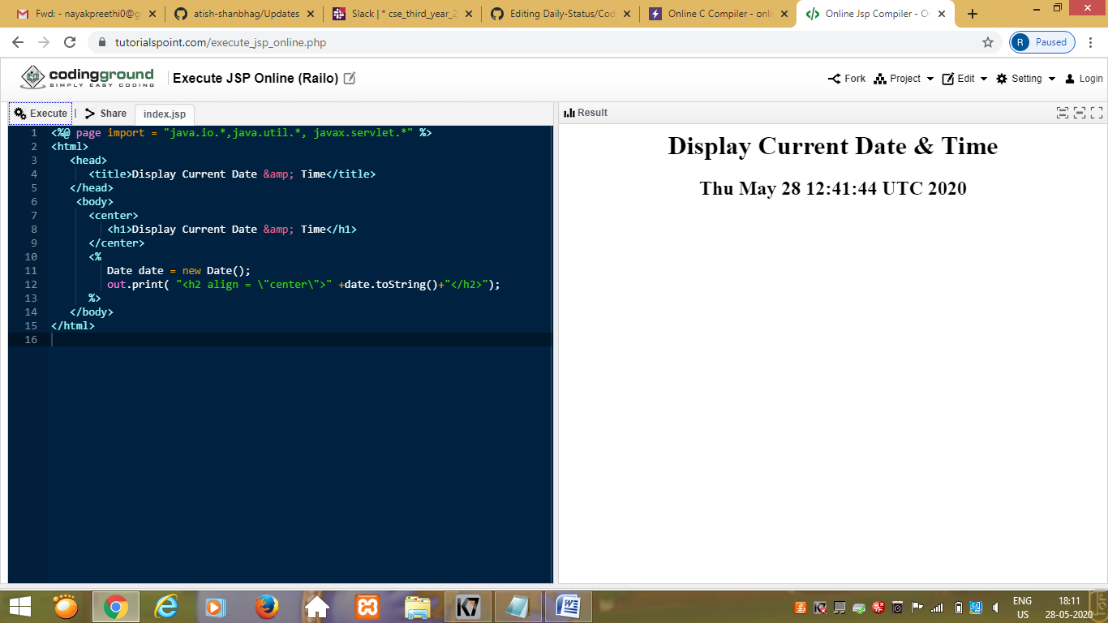

Rani:

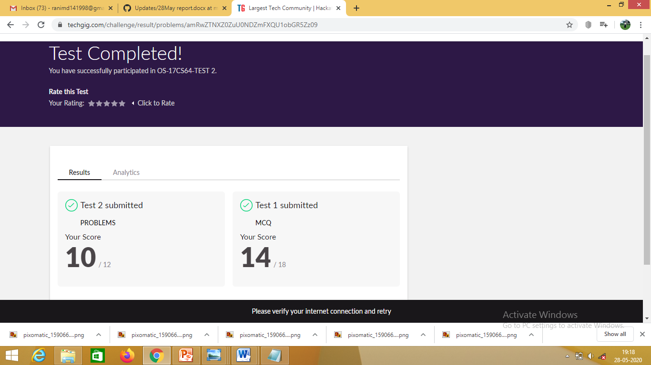



**Pranav L M:**

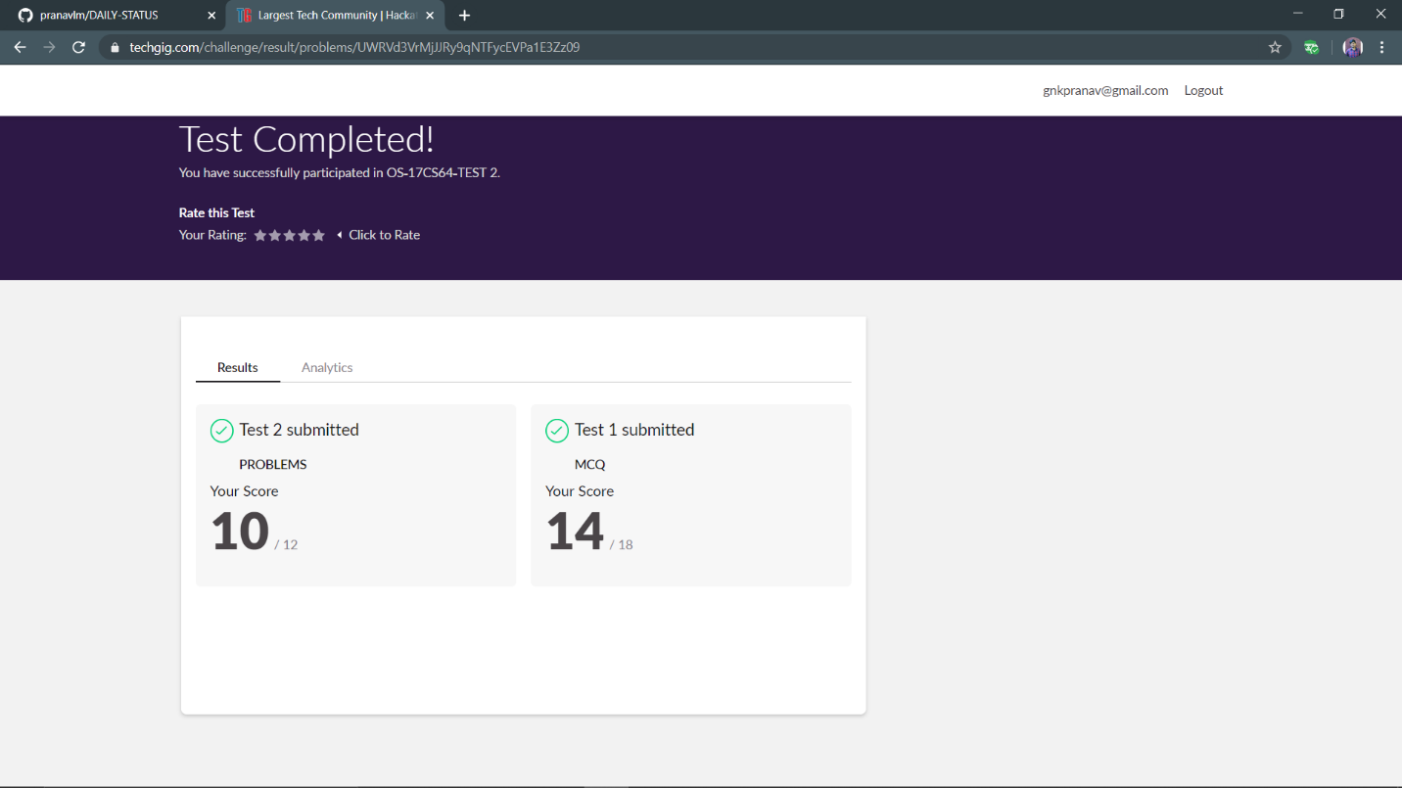

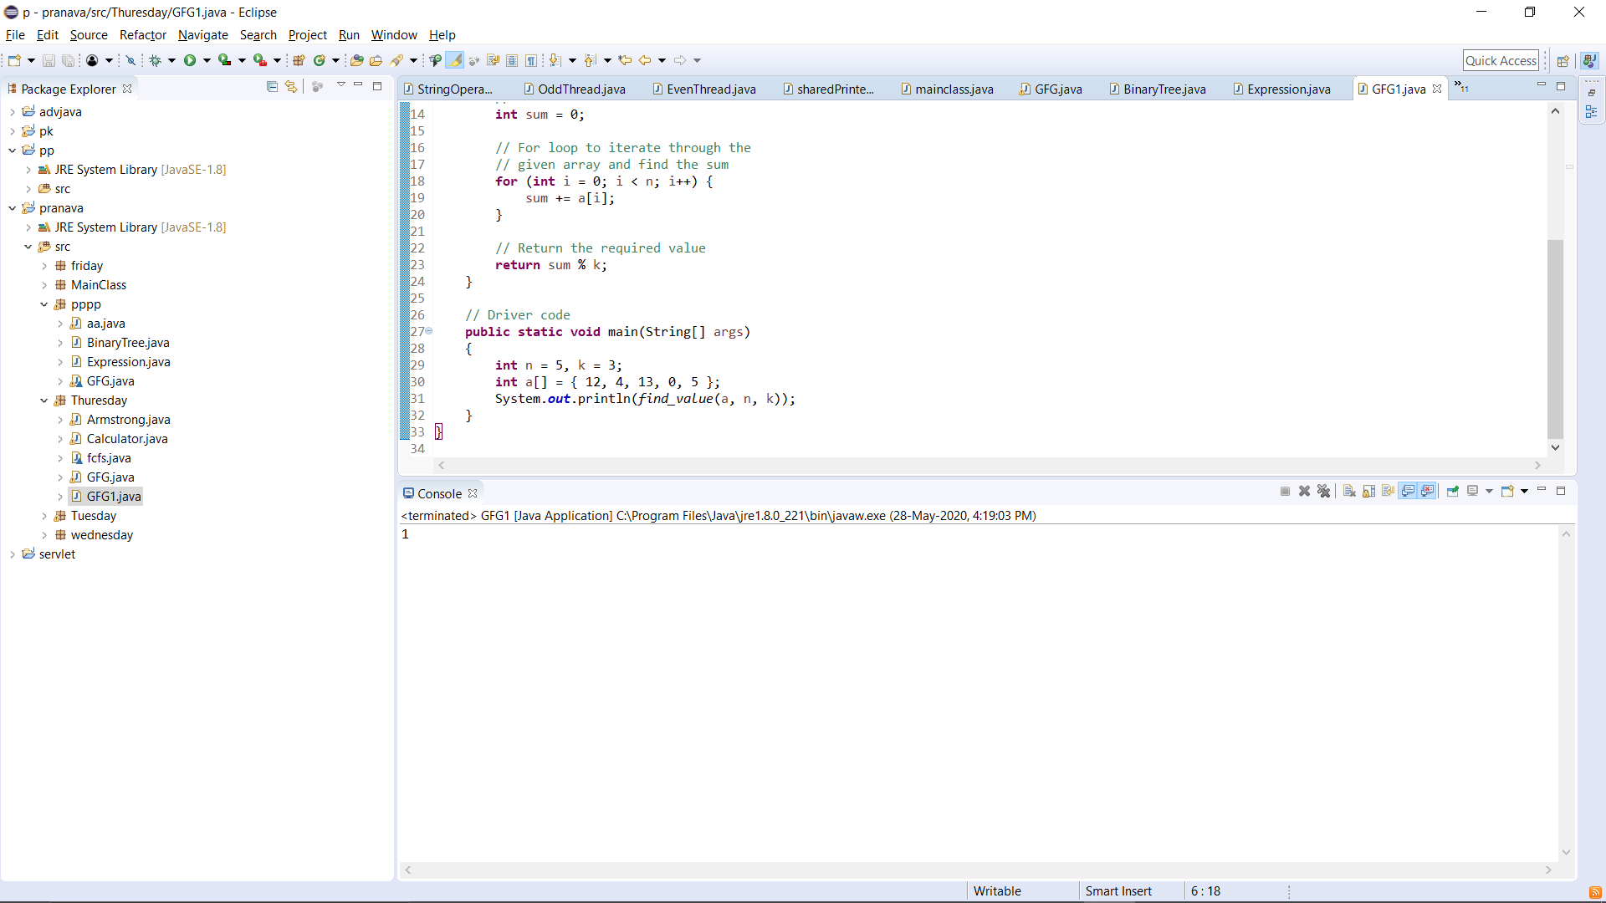

RAVALI:

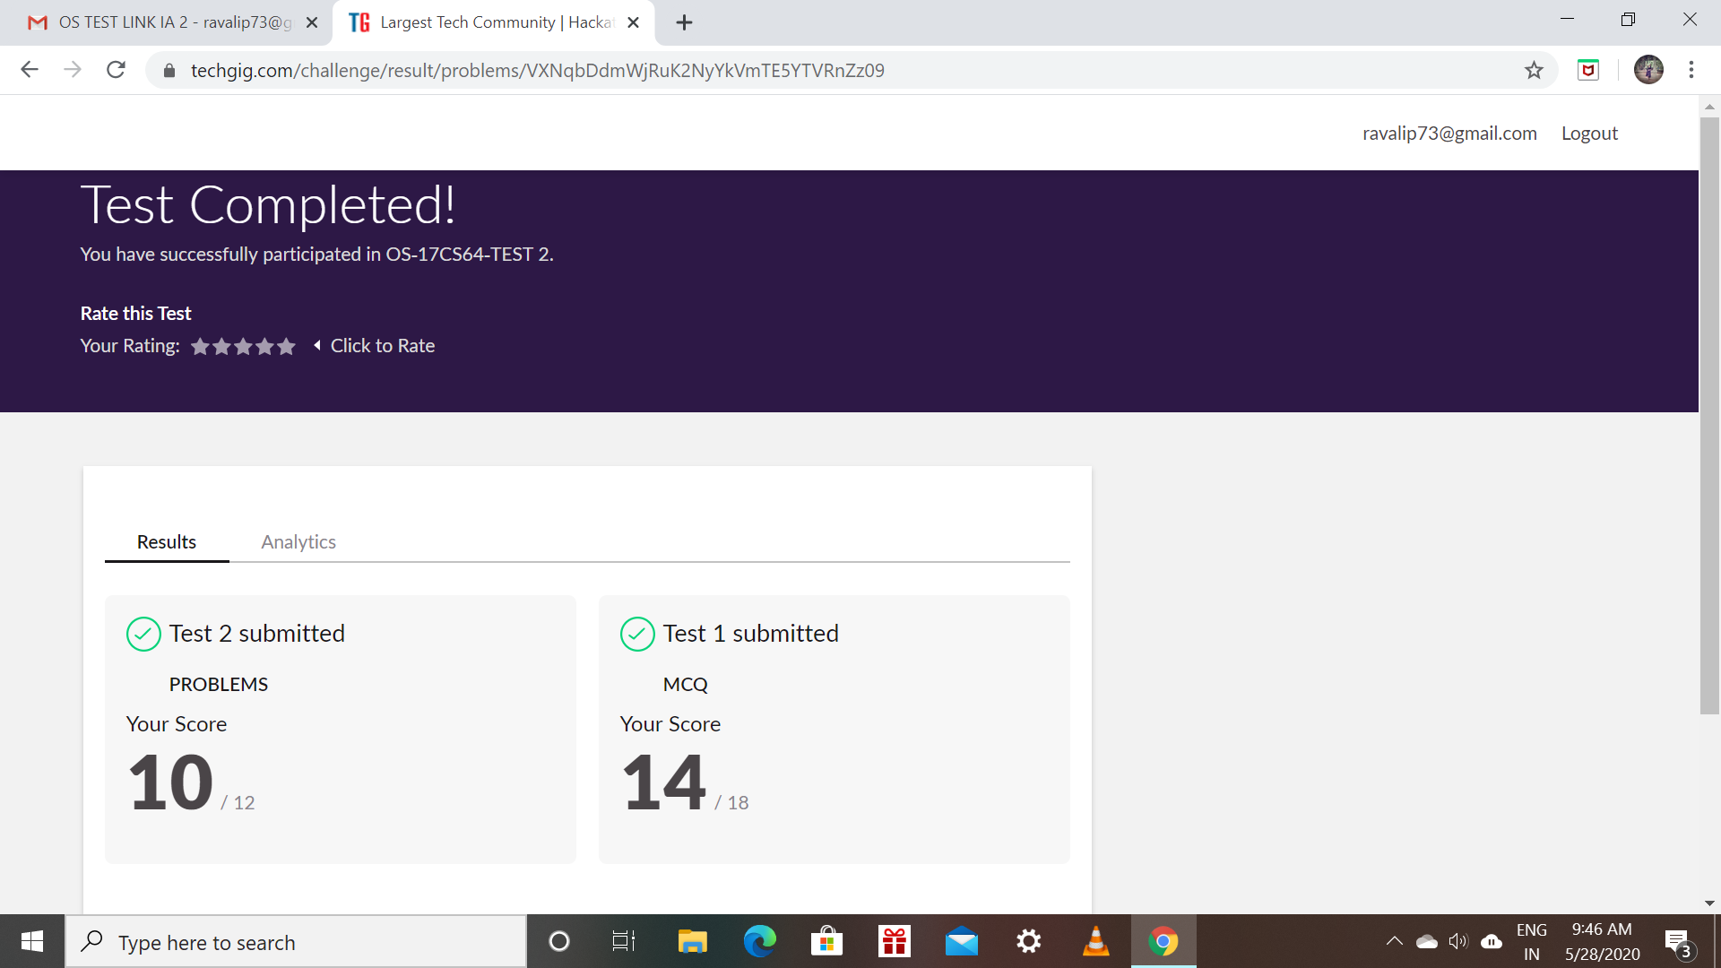

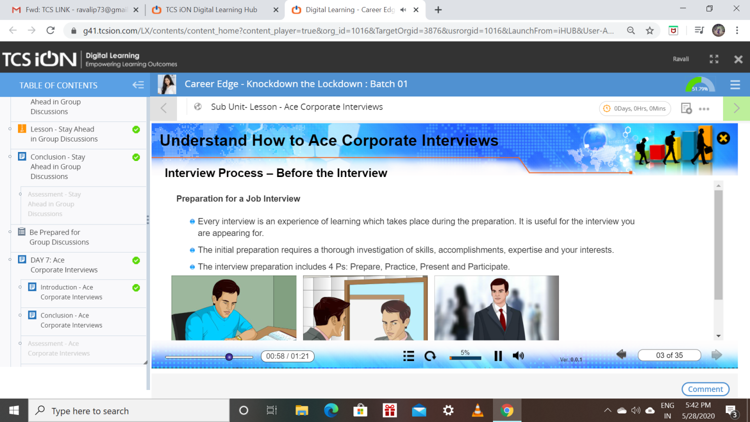

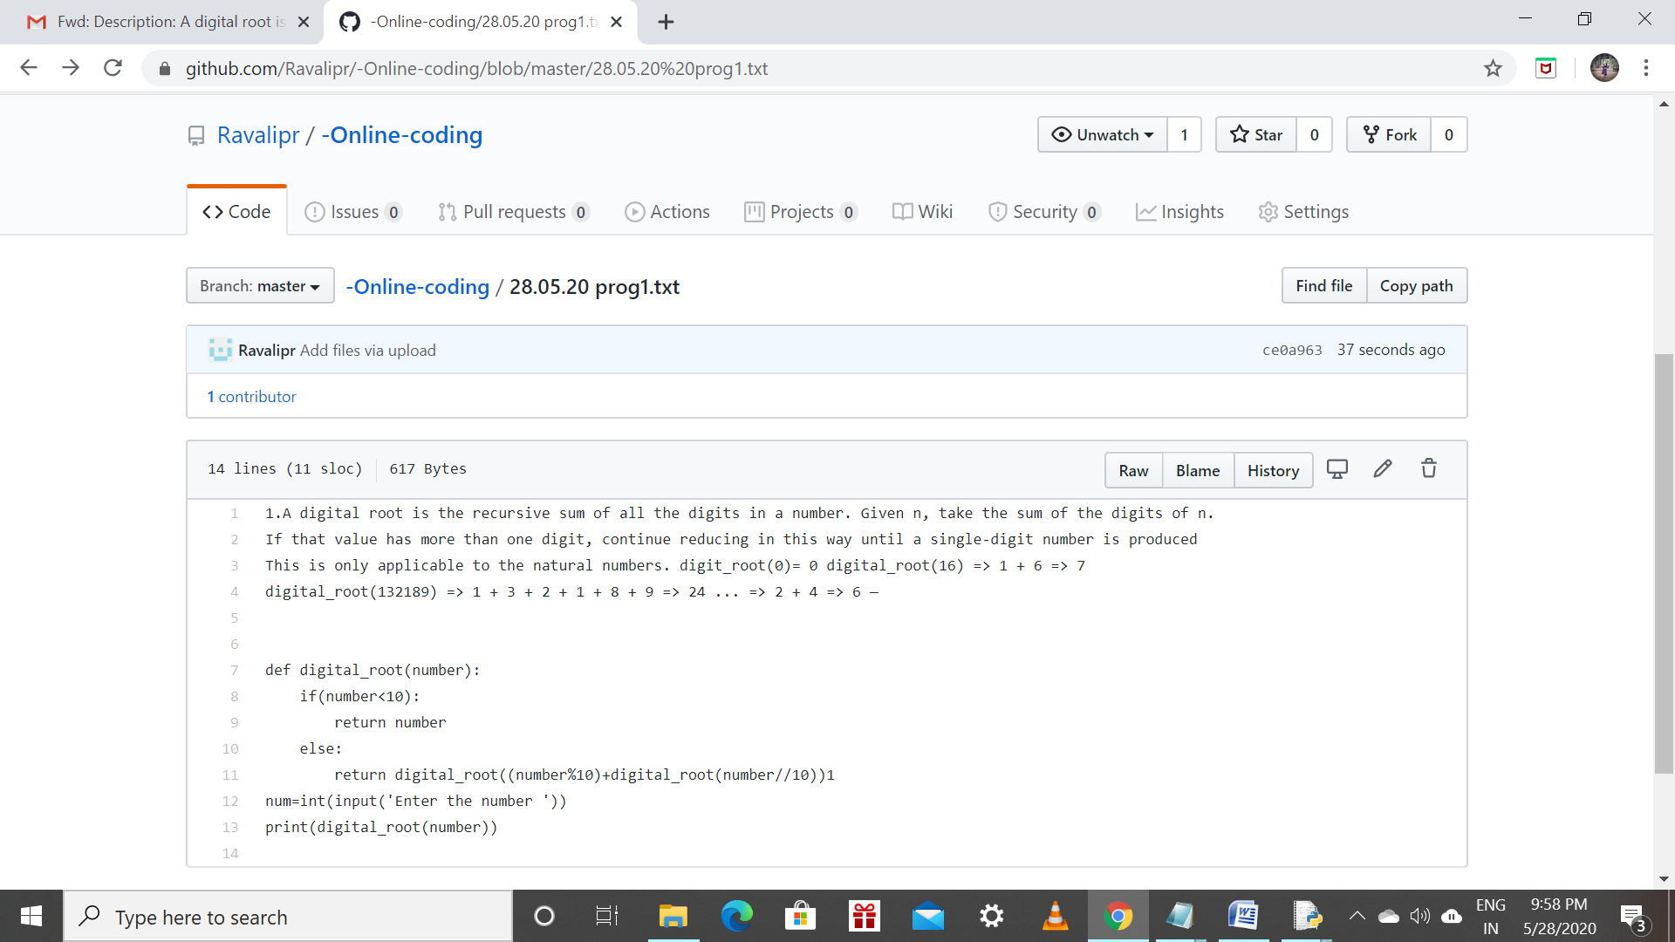

Priyanka:

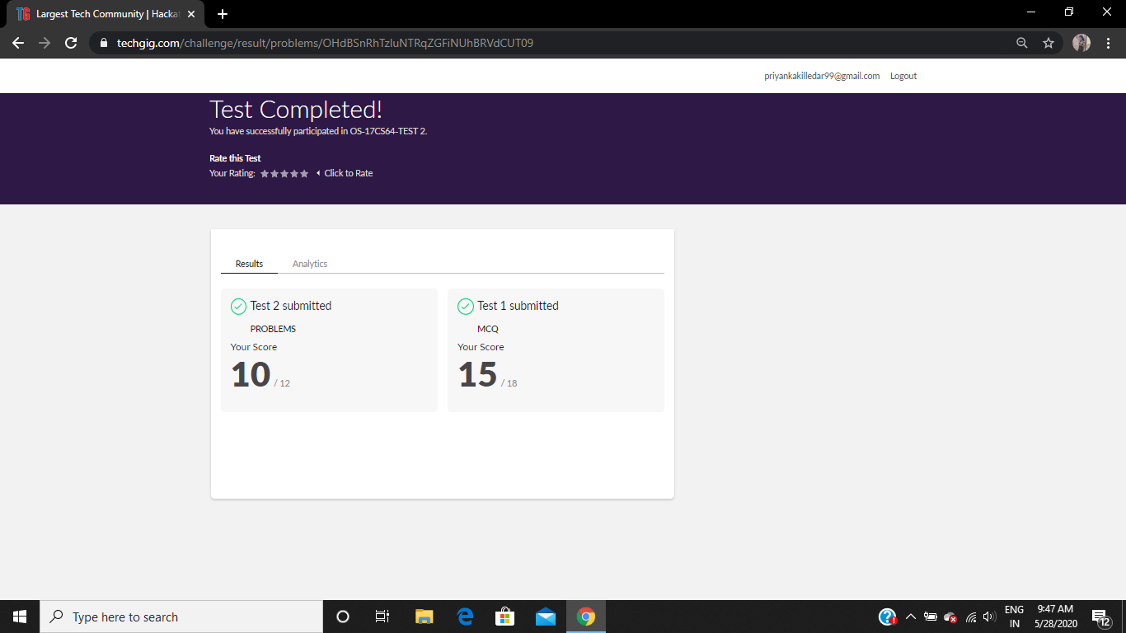

Refer the github link for detail information :<https://github.com/Priya-s-k/Online-coding-updates>

Solved all the problems and the solutions are uploaded in github account.

The same report is also available in github: <https://github.com/Priya-s-k/online-activity-updates>

Priya:

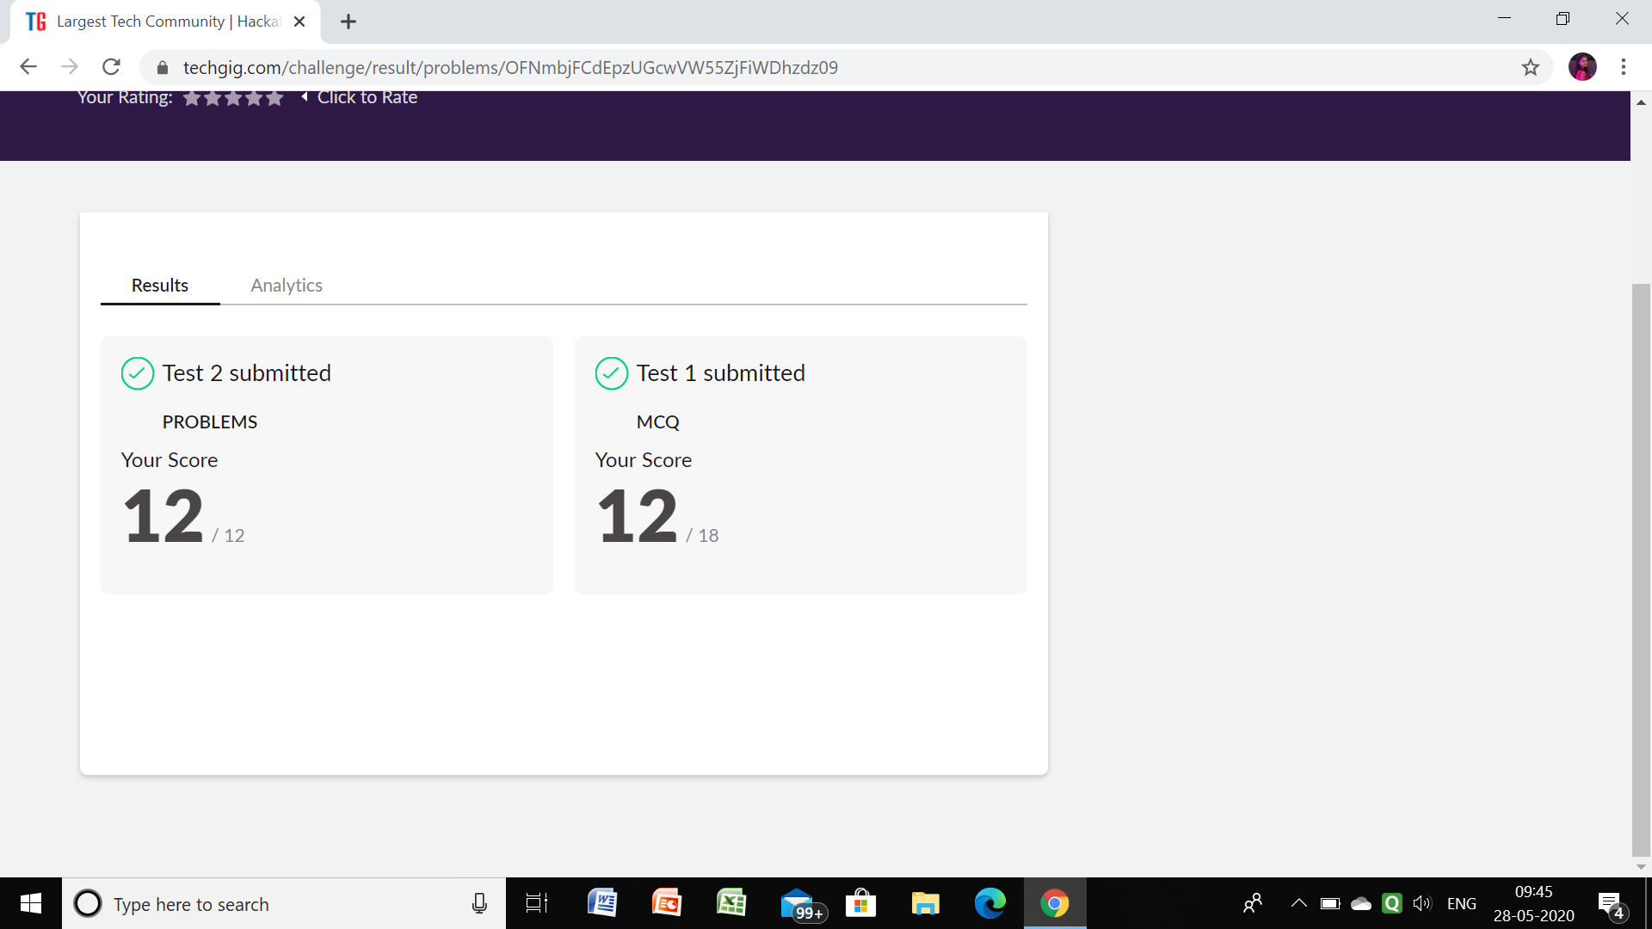

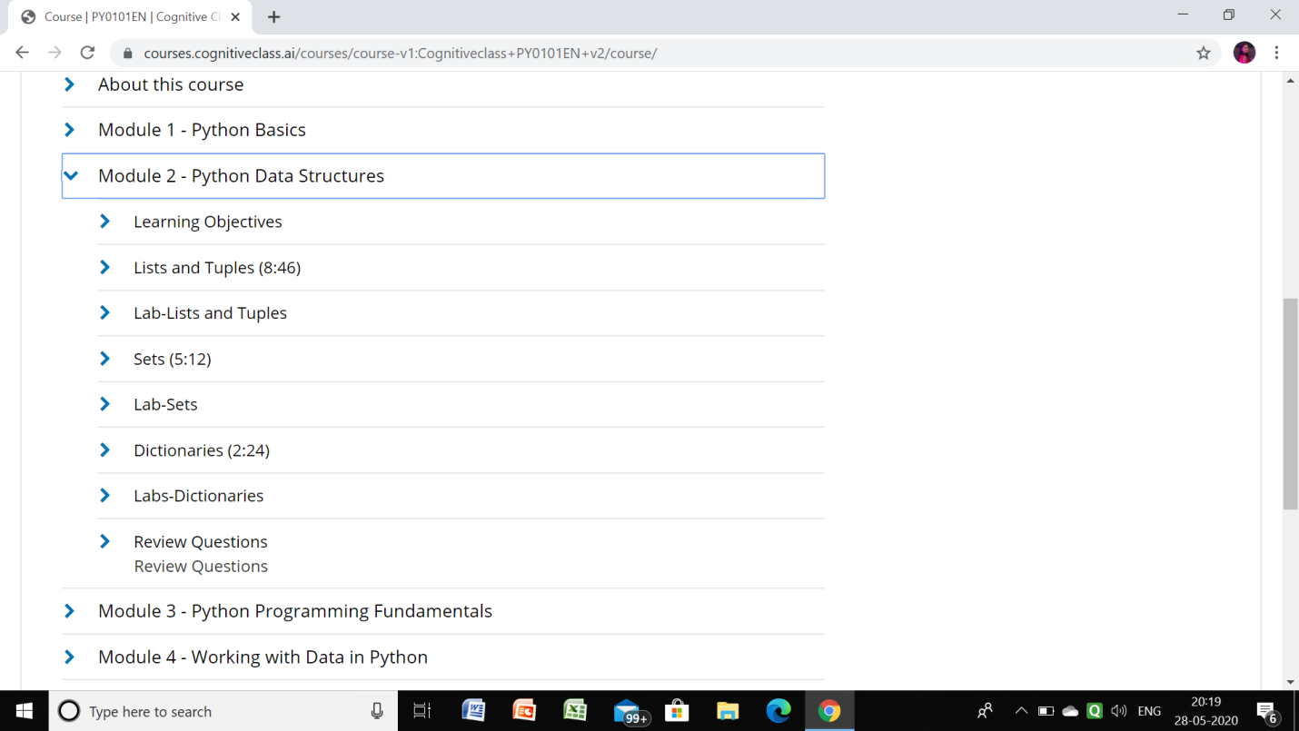

Github link for detail information: <https://github.com/priya3028/Onlinecodingupdate>

Solved and uploaded in github

Rousha:

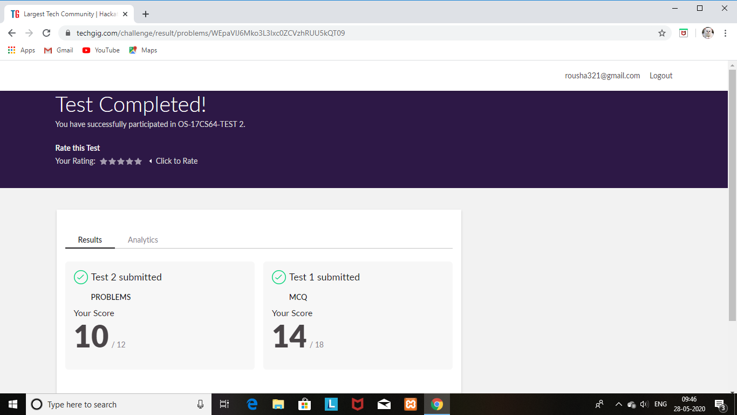

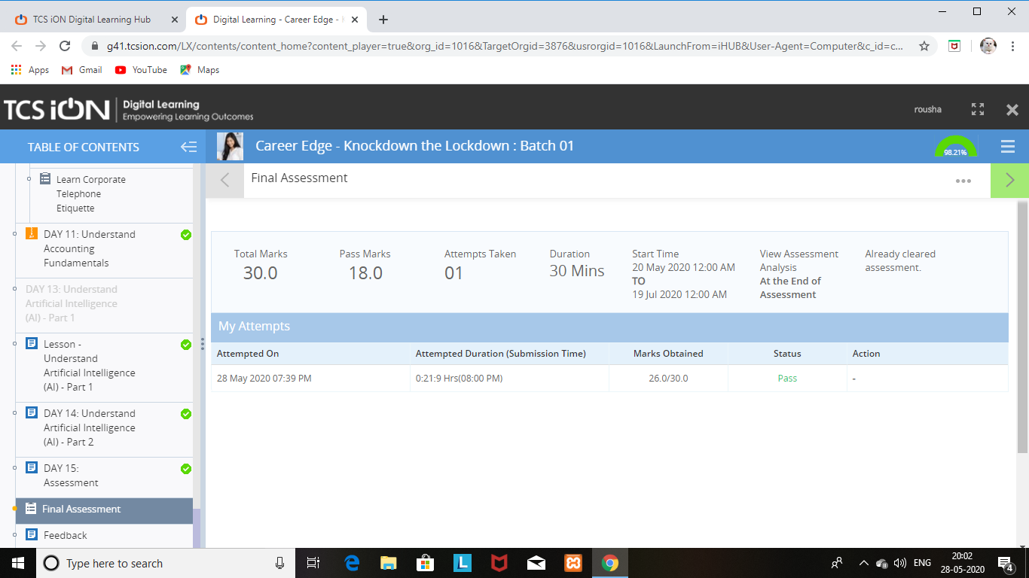

SHAIFA:

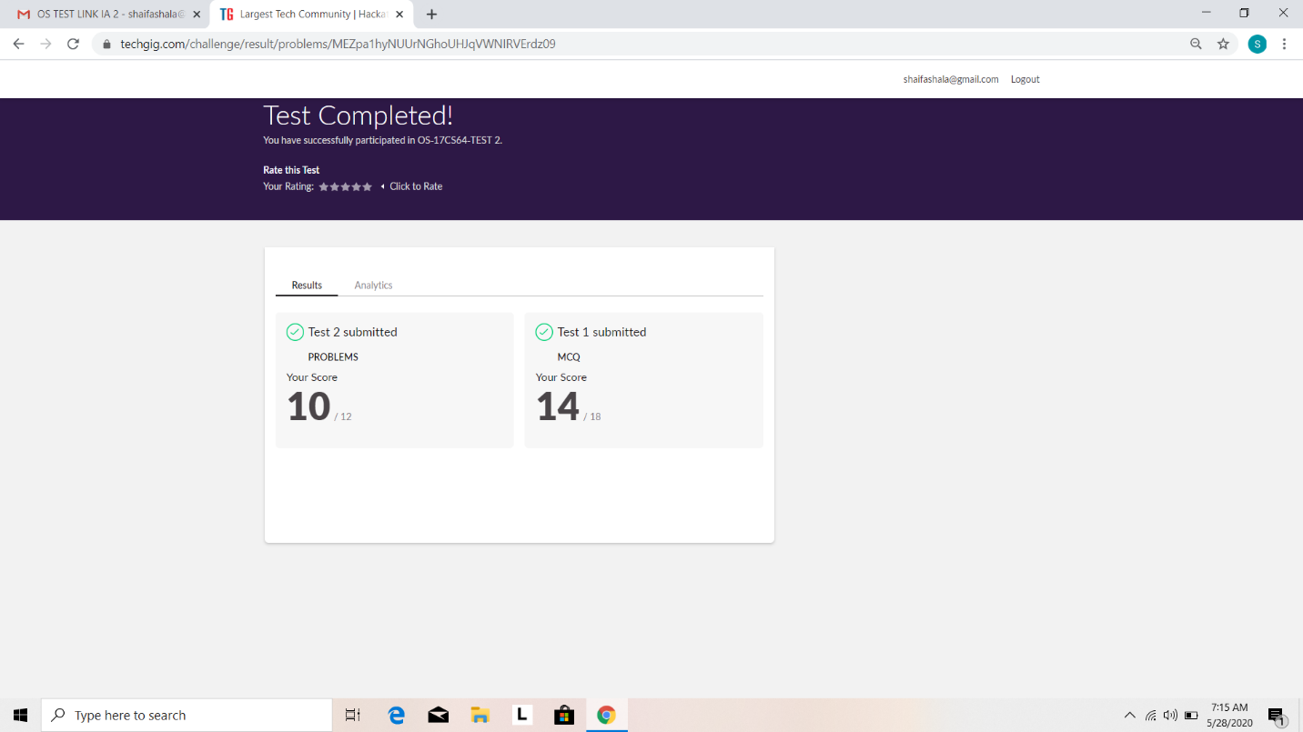

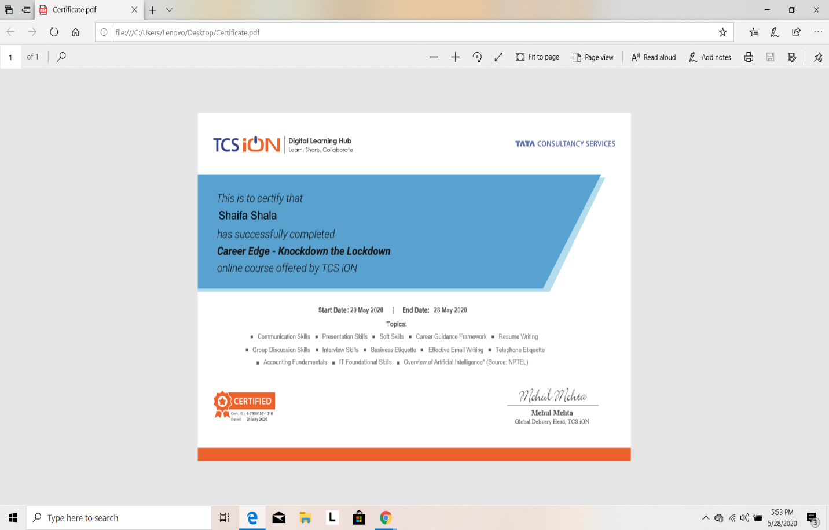

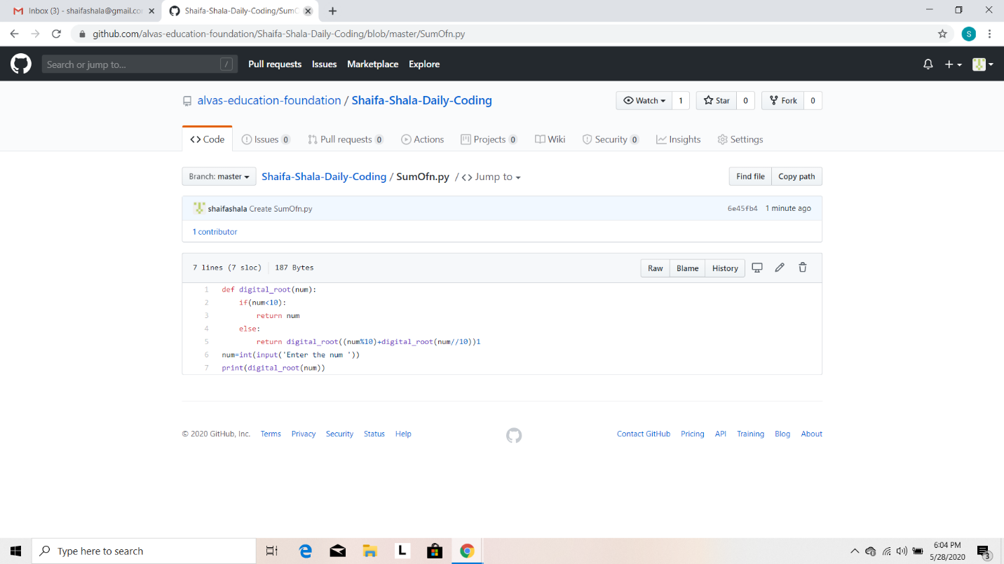

Rani:



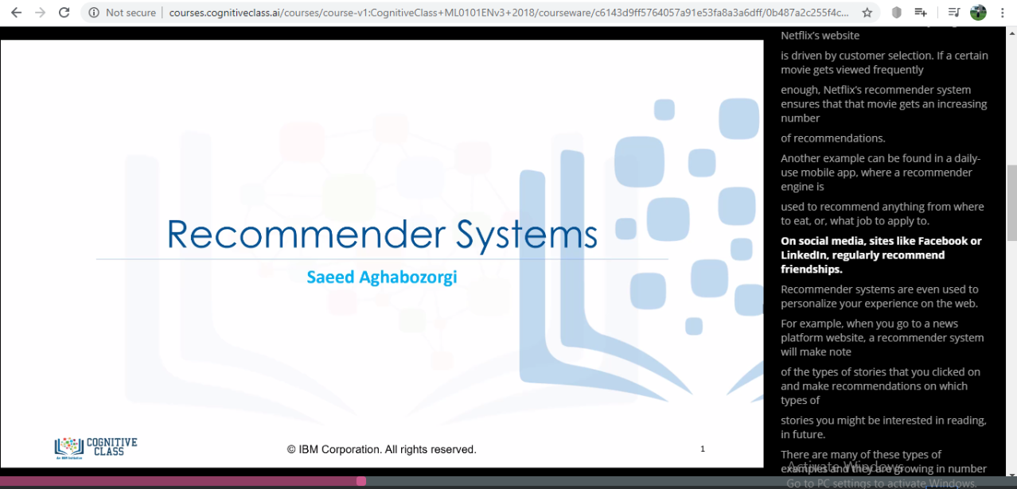

Praveen kumar:

Rohan vasista:

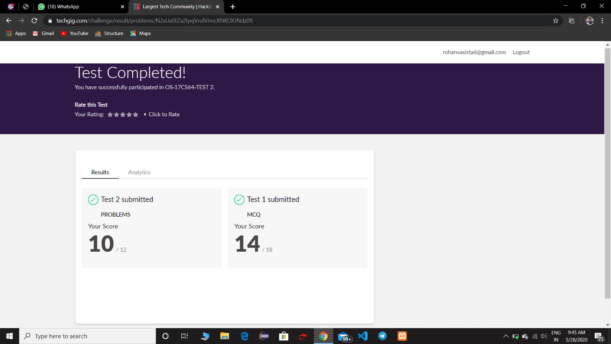

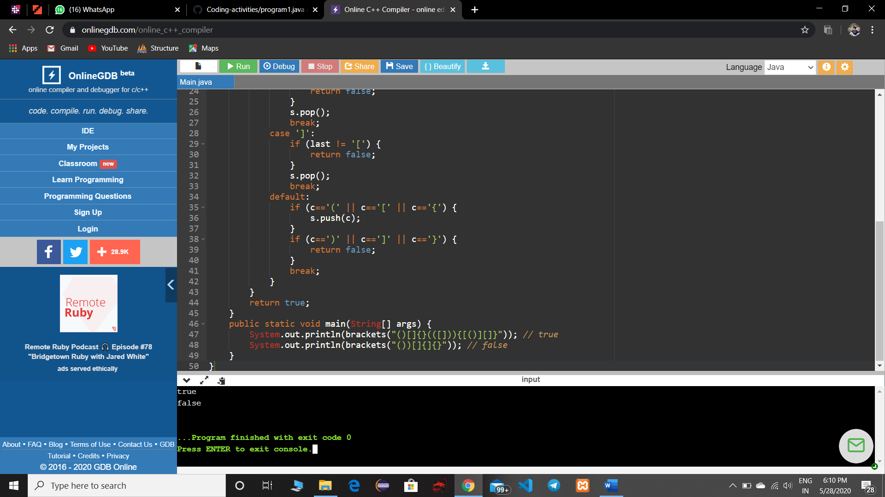

Sana:

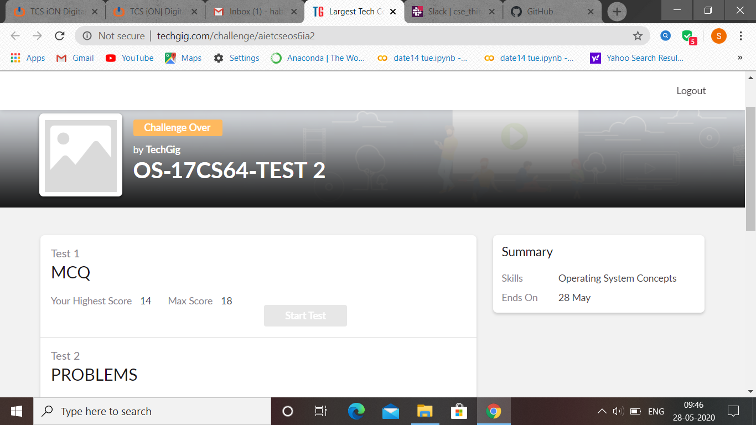

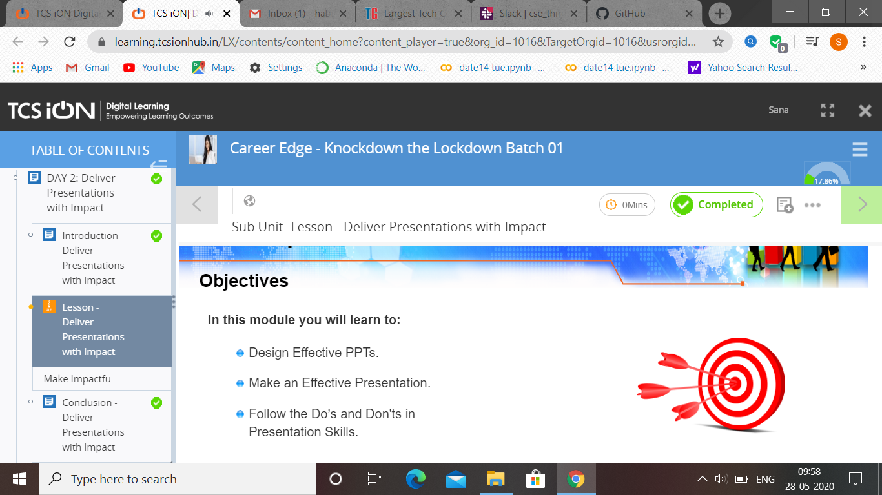Rachana:

**Online Test Details:**

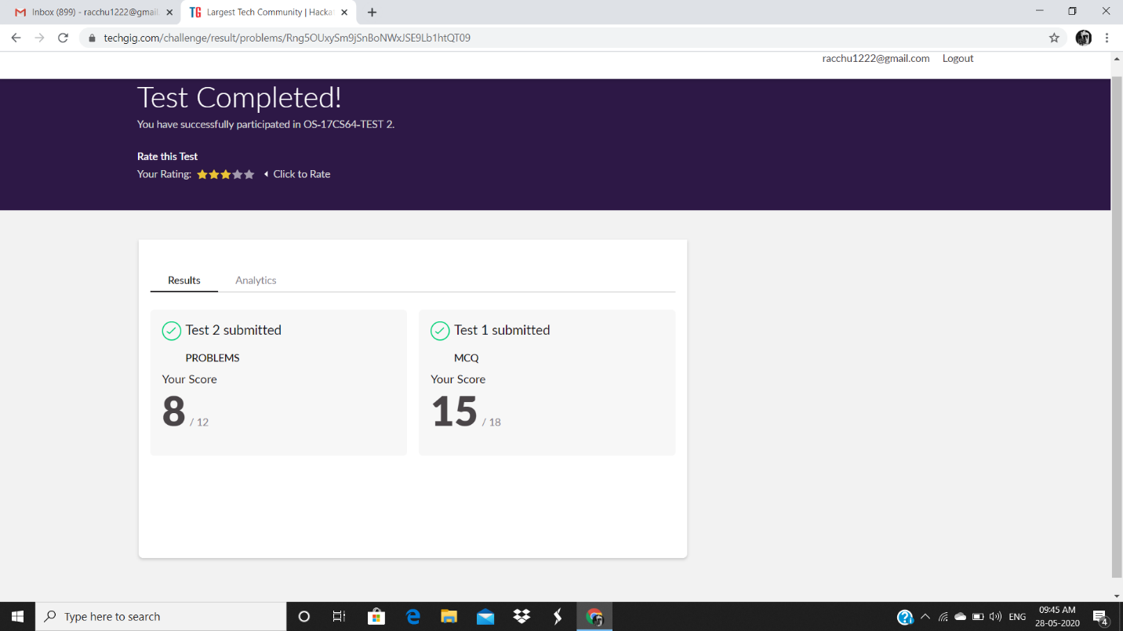

**Certification Course Details:**

**Today Progress:**

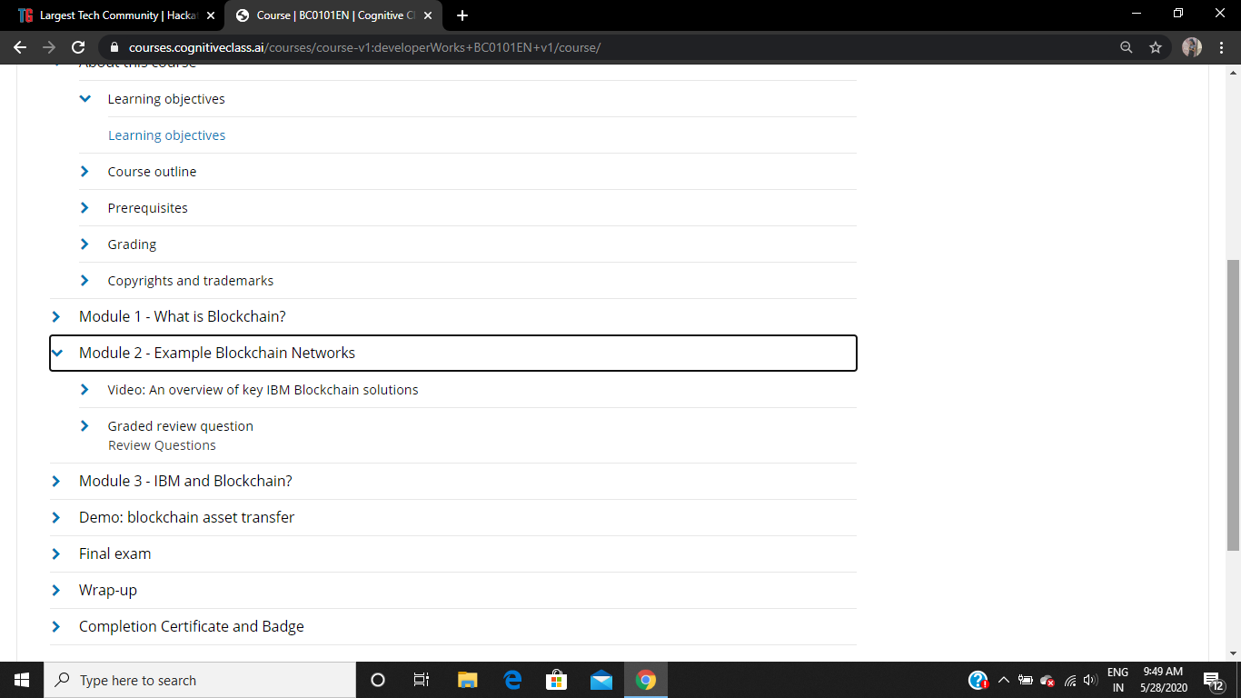

Completed the topics of module 2.

**Coding Challenges Details:**

Refer the github link for detail information : https://github.com/rachnarayan1201/daily_status_coding/commits?author=rachnarayan1201

Solved all the problems and the solutions are uploaded in github account.

Raghavi:

